Signal Processing 2

Project

Giorgi Javakhishvili

Konstantine Kerdikoshvili

Lecturer: Guga Vardiashvili

Introduction

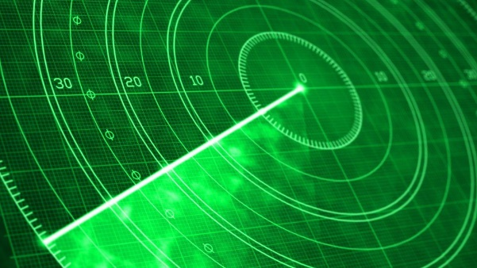Our project focuses on a moving vehicle that travels in a specific direction, with detectors designed to precisely capture its exact location and speed. For this project, we used MATLAB, where the entire codebase was developed. We approached the problem incrementally—breaking down the overarching challenge into smaller, manageable parts—and systematically solved each component.

Working Principles

The system operates based on the physical phenomenon of echo detection. A transmitted signal is highly likely to strike the target object and reflect back. By measuring the time delay between signal transmission and reception, we calculate the distance to the object. To achieve precise location tracking, three detectors are used for triangulation. Once the location is determined at each instance, calculating the object’s velocity becomes straightforward through successive positional updates.

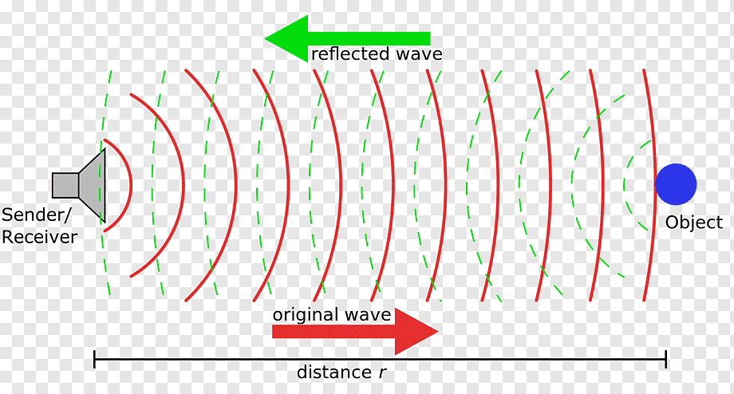

Approach

Given the labor-intensive nature of the project and the near impossibility of direct computation for all components, we divided the problem into the following stages:

1. Noise-Integrated Simulation: Create a simulated environment with realistic background noise.
2. Echo-Based Distance Calculation: Measure distances between points using reflected signals.
3. Triangulation with Three Radars: Precisely locate the object using three detectors (initially focusing on a stationary system).
4. Transition to Motion: Shift from analyzing stationary objects to tracking moving systems, computing real-time coordinates.
5. Velocity & Direction Analysis: Determine the speed and trajectory of the moving object.

Problems and Solutions

1. Noise Corruption:

Problem: Environmental noise corrupts the sinusoidal signal, making detection impossible without Fourier analysis.

Solution: Generated Gaussian noise using MATLAB’s randn (random normal distribution) and awgn (Additive White Gaussian Noise) functions to simulate realistic interference.

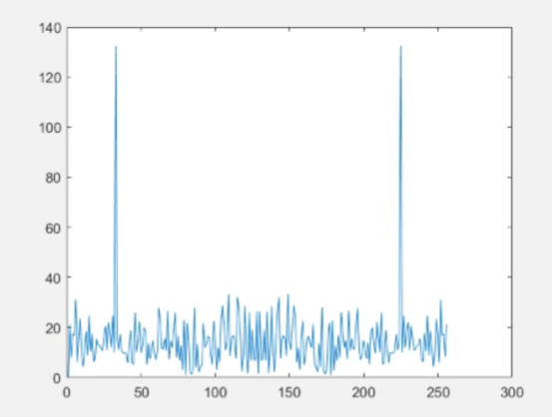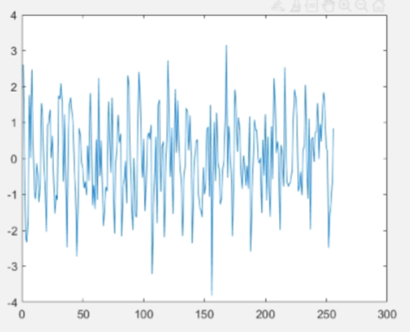

დაბინძურებული სიგნალი და დაბინძურებული სიგნალის fft

1. Problem: Simulating realistic radar echo timing without a physical object.

Solution: Created a virtual "microphone" (matrix) to store incoming signals for each radar. Precomputed distances from a chosen virtual location to each radar. Injected the transmitted signal into the matrix at the precise simulated time it would return as an echo. Divided the matrix into time segments and applied Fourier transforms to isolate and detect the exact moment of signal return.

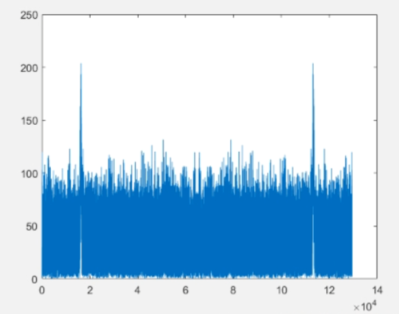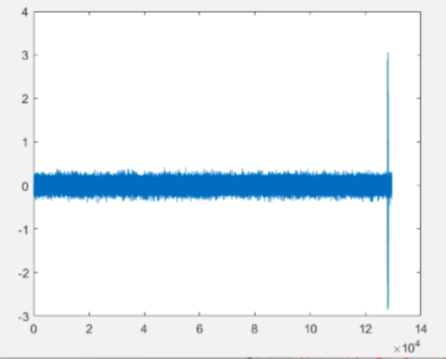

სინგალის რექორდი და მისი ფურიე გარდაქმნა(დემონსტრაციისთვის ხმაურის სიმძლავრე აწეულიგვაქ, რეალურად ამაზე ბევრად ნაკლებია)

1. Using one or even two radars makes it impossible to determine precise coordinates. If two distances are known, meaning we can draw circles around two points, these circles may intersect at one point (which occurs very rarely in practice), two points (which is problematic since we cannot determine which of the two points is correct), or no points at all (which is nearly impossible in this scenario). This is precisely why a third radar is necessary—it helps identify which of the two potential intersection points is valid. (We resolve this ambiguity by comparing distances to both candidate points and solving the system of equations derived from the initial two points.)

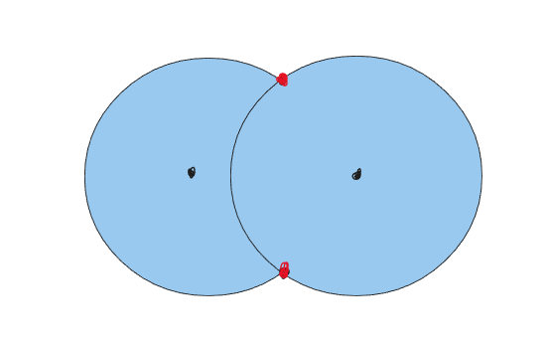

1. When introducing movement to the system, it becomes essential to account for the moving object’s velocity. This allows us to precisely determine both the timing of a potential collision and the distance between the radar and the object at that critical moment. (To achieve this, we developed a system of equations that solves for time. Multiplying this time value by the object’s speed yields the required distance.)

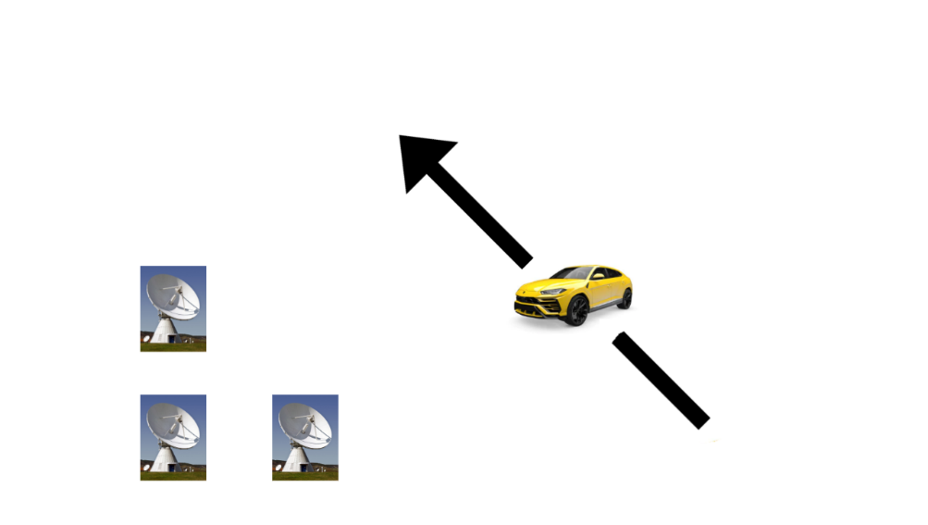

1. During motion, it is essential to account for the Doppler effect, which causes a frequency shift in the signal. To address this, we needed to generate a modified sinusoidal signal. (Using the 2D Doppler effect formula, we calculated the new frequency to adjust our signal generation accordingly.)

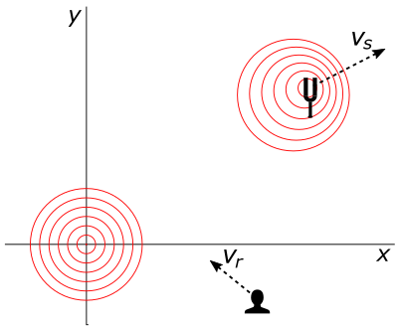

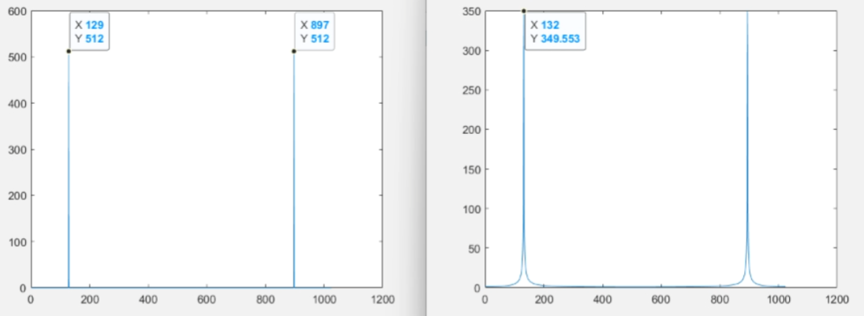

დოპლერის ეფექტით დაშიპტული სიგნალის ფურიე, დემონსტრაციისთვის გაზრდილია მოძრავი ობიექტის სიჩქარე

Summary

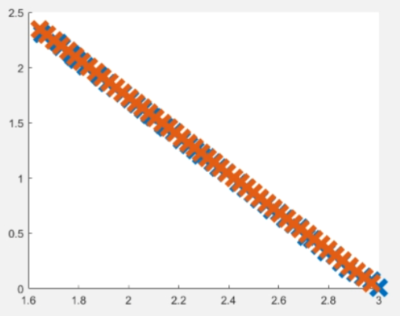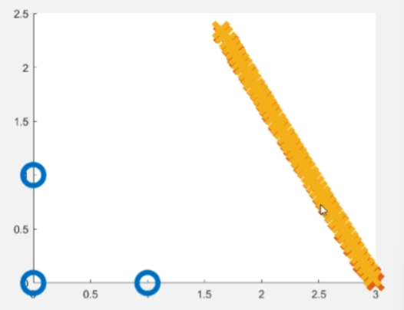 This project synthesizes knowledge from signal processing, engineering, physics, and mathematics. It is precisely this interdisciplinary integration that we believe makes the outcome uniquely compelling.

საბოლოო შედეგი, უბრალოდ დატანილი n=50-ისთვის და რადარებთან ერთად იგივე(ლურჯი ჩვენია, წითელი რეალური)